EXPENSE SPLITTER
@CREATIVITY THINK (9483175986/7019689991)

ABSTRACT:
Expense Splitter is a web application designed to simplify group expense management for housemates, friends, or small teams. Users can create or join groups, enter shared expenses, calculate fair splits, settle balances, and view detailed reports on their dashboards. Administrators can manage groups, oversee user settlements, and analyze analytics. Built with Django and Django Rest Framework for backend operations, and React with Redux and Recharts for frontend dashboards, the platform provides a seamless, real-time solution for tracking group expenses, ensuring fairness, transparency, and efficiency in cost sharing..

INTRODUCTION OF THE PROJECT:
Managing shared expenses manually can lead to confusion, disputes, and errors. Expense Splitter addresses these issues by providing a centralized web platform for group expense management. Users can create or join groups, input expenses, calculate fair splits, settle balances, and track all financial interactions through an intuitive dashboard. Administrators manage group settings, monitor settlements, and generate analytics reports. Using Django for backend services and React with Redux and Recharts for dynamic dashboards, the system ensures accurate calculations, transparent tracking, and streamlined expense management for small groups..

PROJECT OBJECTIVES:

• Provide a platform to create and join expense-sharing groups
• Enable users to enter shared expenses easily
• Calculate fair splits and settlements automatically
• Allow users to view expense reports and summaries
• Provide administrators with tools to manage groups and settlements
• Generate analytics dashboards for financial insights
• Improve transparency and reduce disputes in group expenses

PROBLEM OF THE STATEMENT:
Housemates, friends, or small teams often struggle to manage shared expenses manually, which can lead to miscalculations, delayed settlements, and disputes. Existing solutions may be fragmented or difficult to track in real time. Expense Splitter solves these problems by offering a centralized, web-based system that records expenses, calculates fair splits automatically, tracks settlements, and provides transparent reporting. Administrators can manage groups, oversee user settlements, and generate analytics, ensuring fair and efficient financial management for all group members..

MOTIVATION OF THE PROJECT:
• Simplify expense tracking for groups and teams
• Automate fair expense splitting and settlements
• Reduce errors and conflicts in manual calculations
• Provide real-time dashboards for tracking expenses
• Offer administrators analytics and control over group finances

BLOCK DAIGRAM OF PROJECT:

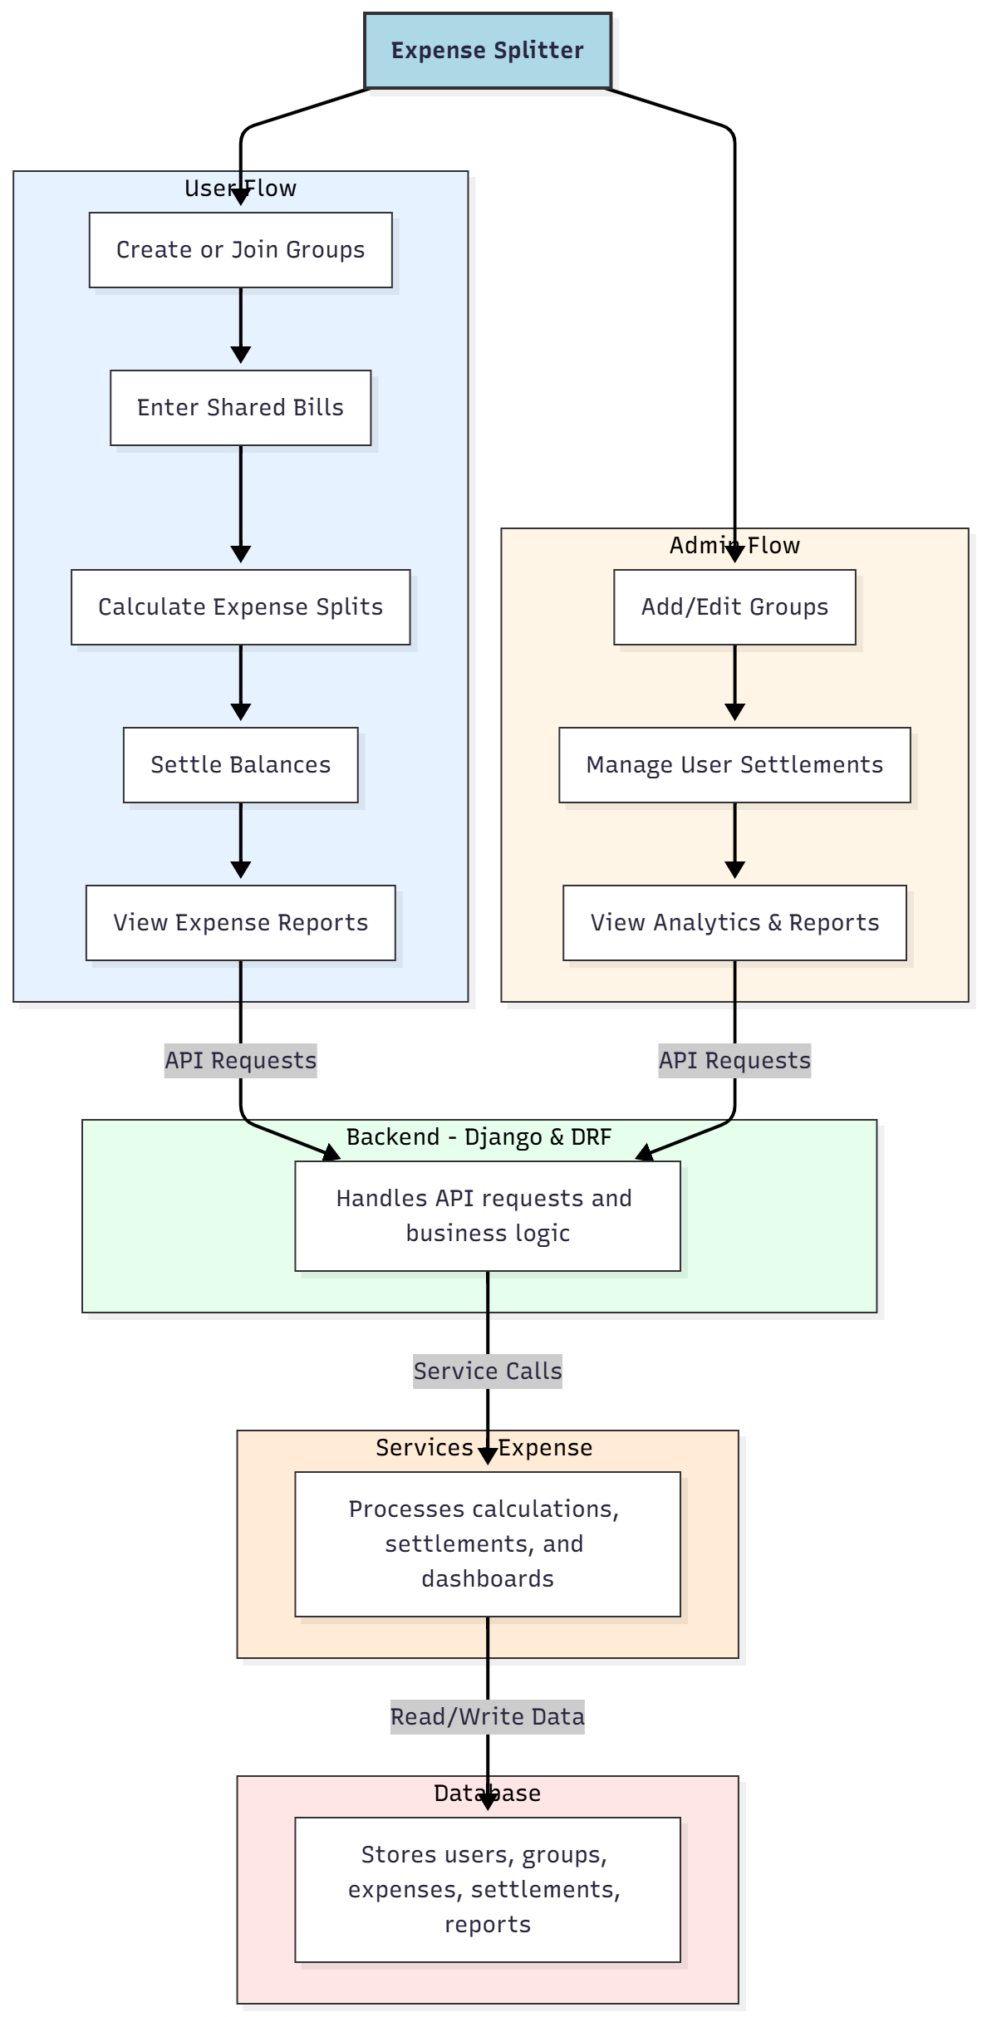

WORKING OF THE PROJECT:
Users create or join groups, enter shared bills, calculate fair splits, settle balances, and view comprehensive expense reports. The backend handles authentication, API requests, and expense logic. Services manage calculations, settlements, and dashboard analytics. Administrators add or edit groups, manage user settlements, and generate analytics reports. This integrated system ensures accurate, real-time expense tracking, fair settlements, and transparent reporting for all group members..

SOFTWARE REQUIREMENT:
- Backend:
  - Python 3.x
  - Django
  - Django REST Framework
  - SQLite/PostgreSQL
- Frontend:
  - Node.js and npm
  - React.js
  - Axios
- Development Tools:
  - Visual Studio Code
  - Postman (for testing APIs)
  - Git/GitHub (for version control)
- Server/Deployment (Optional):
  - Gunicorn, Nginx, or Heroku/AWS for hosting

ADVANTAGES OF THE PROJECT:

• Simplifies group expense management
• Automatic fair split calculations
• Tracks settlements and balances
• Provides detailed expense reports and dashboards
• Reduces conflicts in shared expenses
• Centralized platform for groups and admins
• Supports analytics for group spending
• Improves transparency and efficiency in expense management

APPLICATIONS OF THE PROJECT:
• Housemates sharing monthly bills
• Friends sharing trip or outing expenses
• Small team project expenses
• Club or community group expense management
• Freelance team collaboration
• Event or party cost sharing
• Dashboard analytics for financial planning
• Settlement tracking for groups

REFERENCES:

- Django REST Framework Documentation — Django Software Foundation. Django Documentation. Available: https://docs.djangoproject.com/
- Django REST Framework. DRF Documentation. Available: https://www.django-rest-framework.org/
- React. React Official Documentation. Available: https://reactjs.org/docs/getting-started.html
- Redux. Redux Documentation. Available: https://redux.js.org/introduction/getting-started
- PostgreSQL Global Development Group. PostgreSQL Documentation. Available: https://www.postgresql.org/docs/
- MySQL. MySQL Reference Manual. Available: https://dev.mysql.com/doc/
- Git. Git Documentation. Available: https://git-scm.com/doc
- Node.js. Node.js Documentation. Available: https://nodejs.org/en/docs/
- Axios. Axios Documentation. Available: https://axios-http.com/docs/intro
- Socket.io Documentation – https://socket.io/docs/

